8.2D – 1 (R) one Y
8.2D – 1 (R) two Z
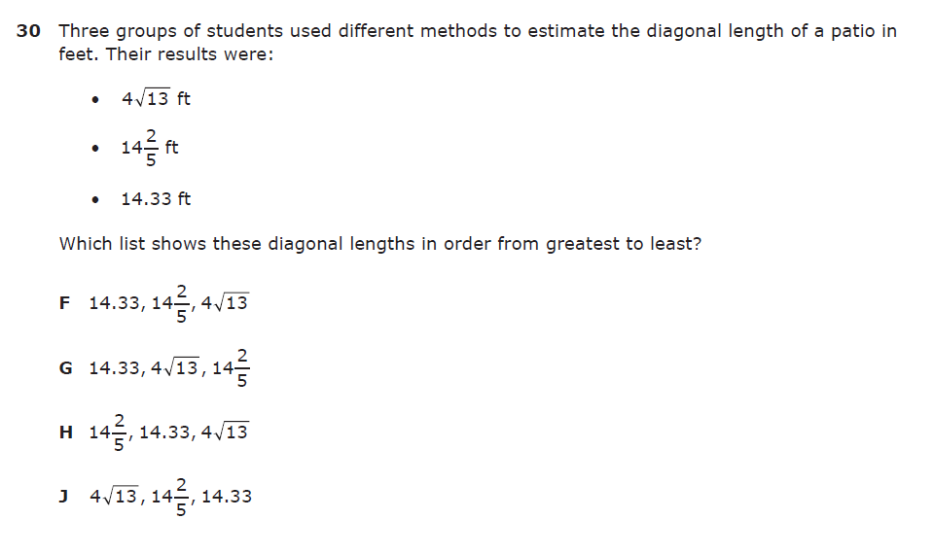
8.2D – 1 (R) three Y
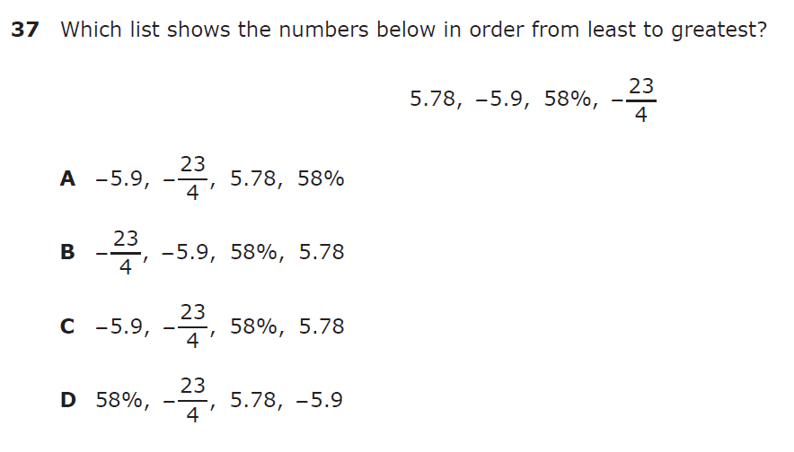

8.2D – 1 (R) four Y
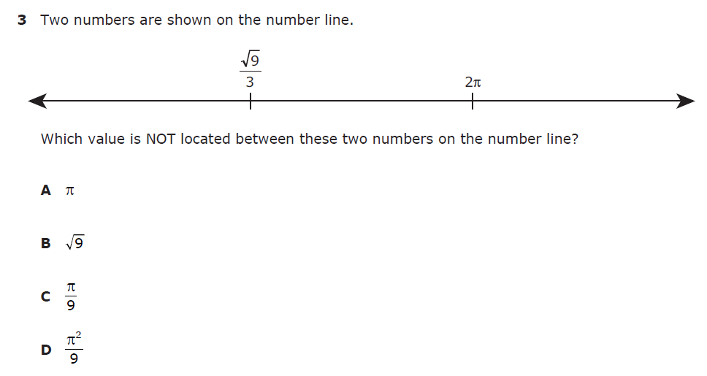

8.2D – 1 (R) five Z

8.2D – 1 (R) six X
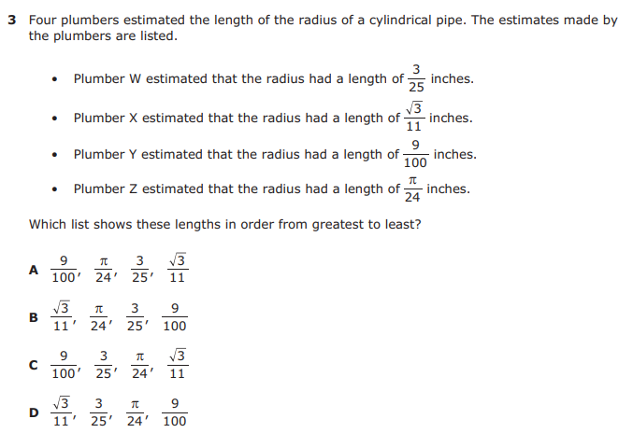

8.2D – 1 (R) seven Y
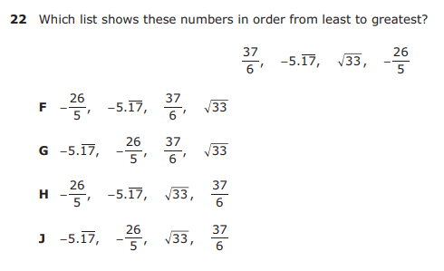

8.3C – 3 (R) eight X
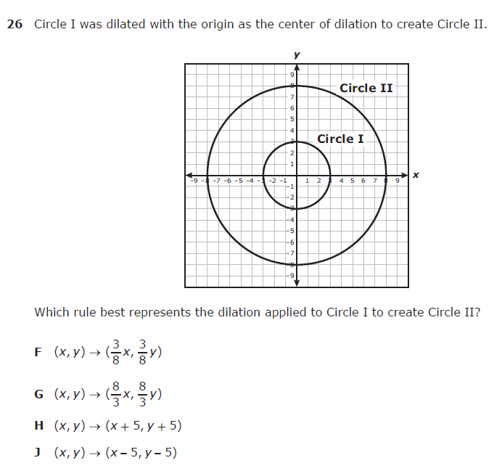
8.3C – 3 (R) nine W
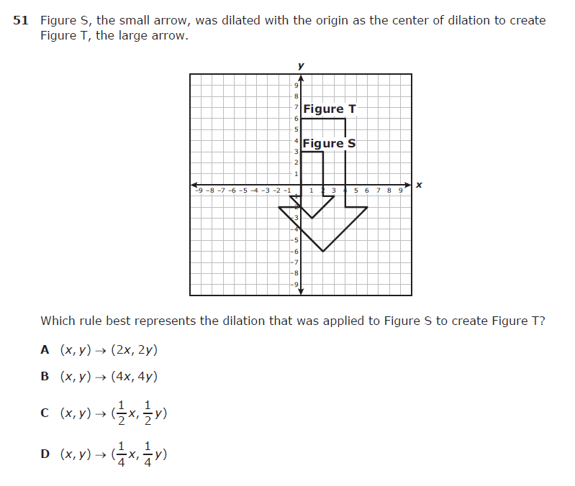
8.3C – 3 (R) ten Z
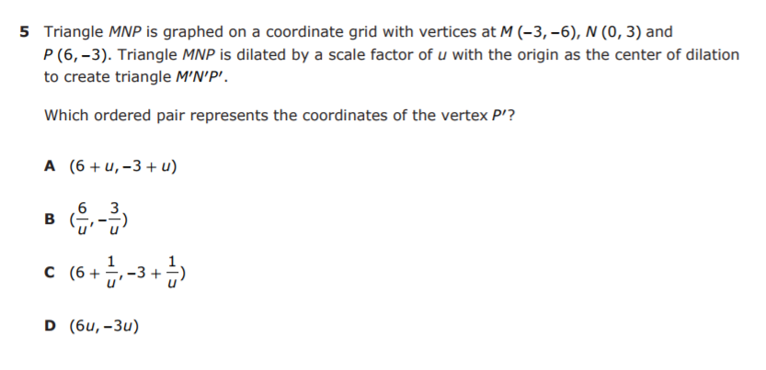

8.3C – 3 (R) eleven Y
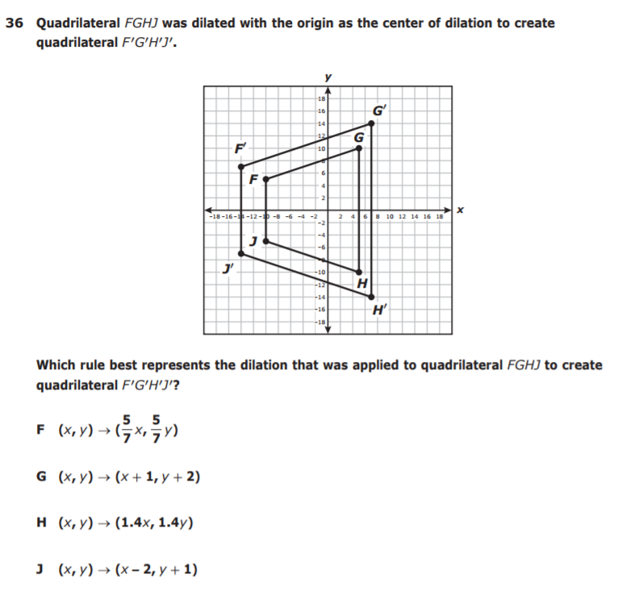
8.3C – 3 (R) twelve Z
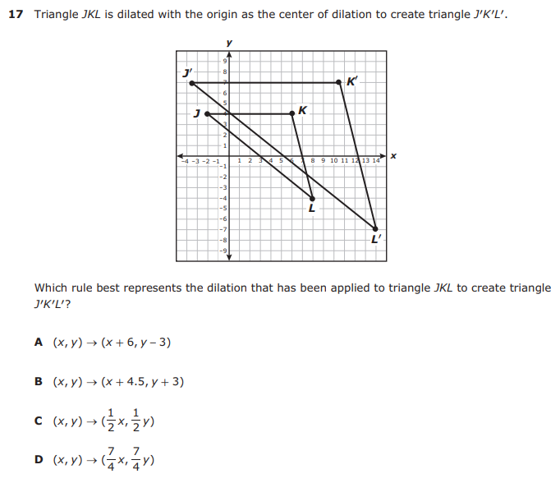
8.3C – 3 (R) thirteen X
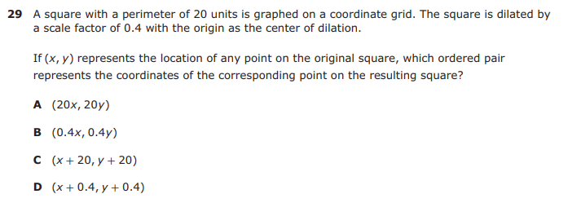

8.4B – 2 (R) fourteen Z
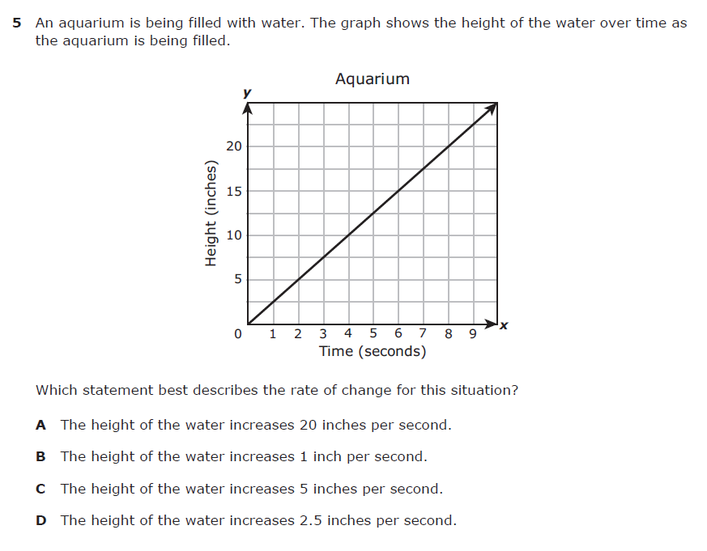
8.4B – 2 (R) fifteen X
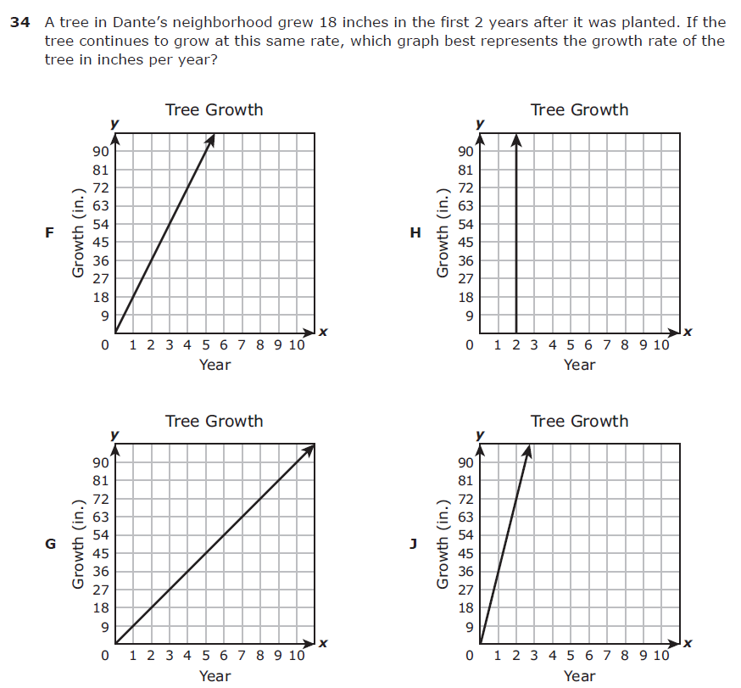
8.4B – 2 (R) sixteen Y
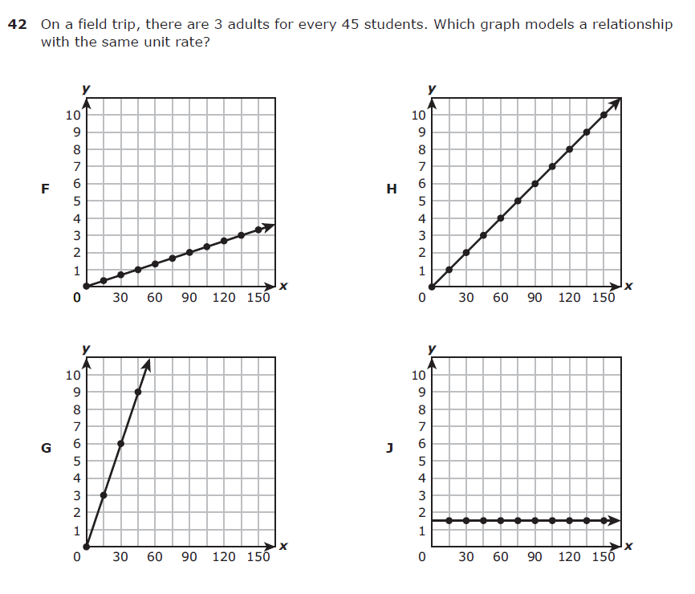
8.4B – 2 (R) seventeen W
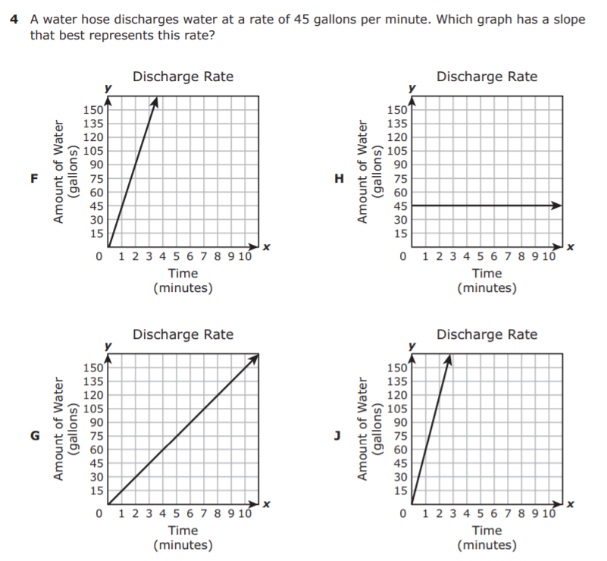
8.4B – 2 (R) eighteen W
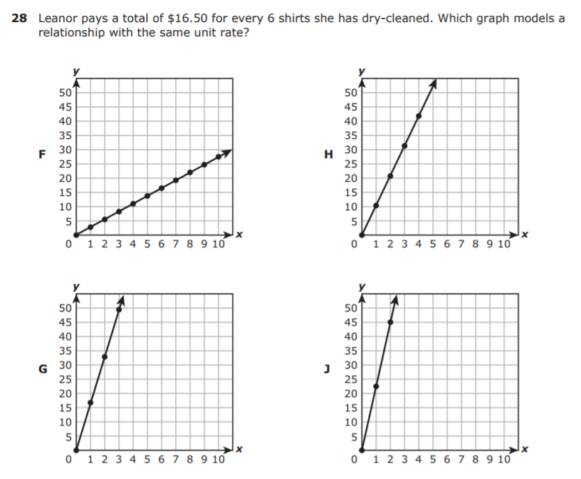
8.4B – 2 (R) nineteen X
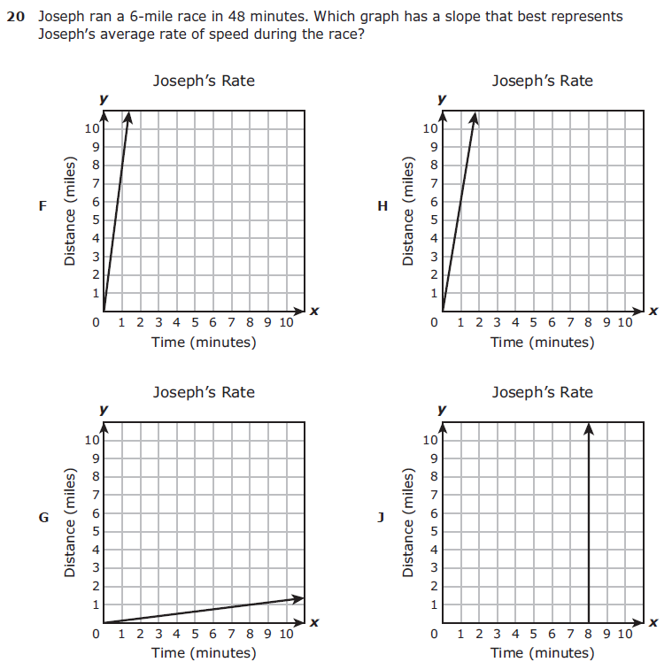
8.4B – 2 (R) twenty Y
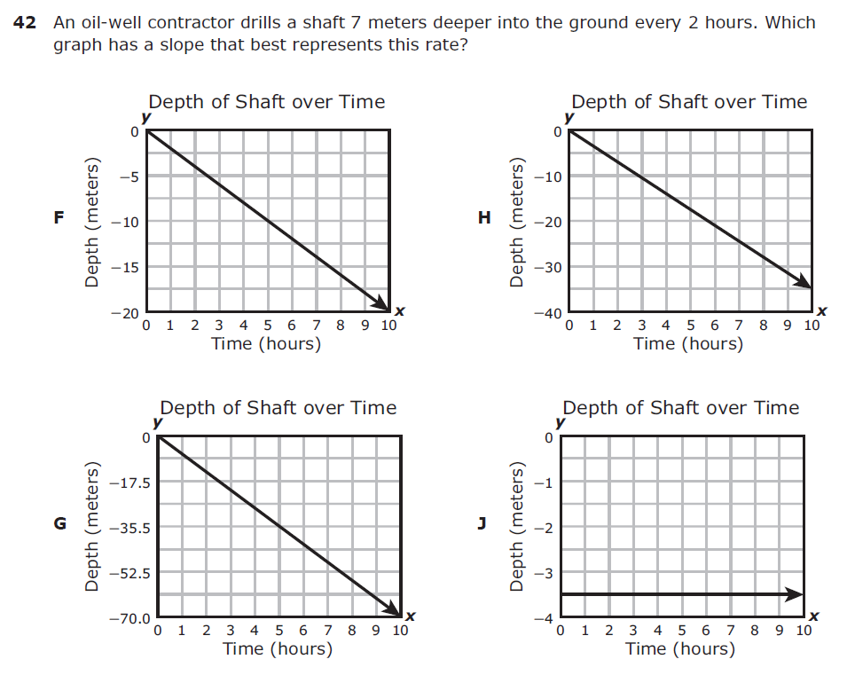
8.4C – 2 (R) twenty one Y
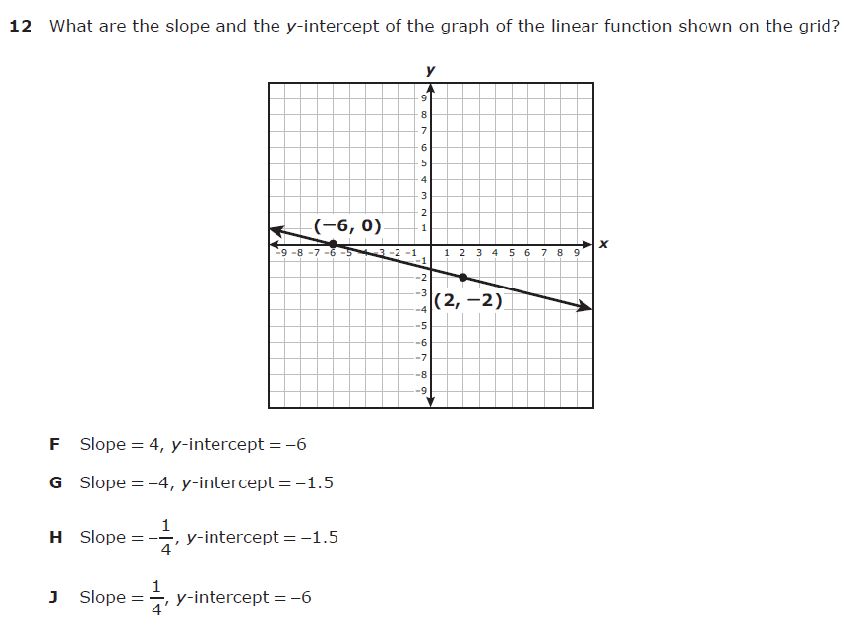
8.4C – 2 (R) twenty two -6
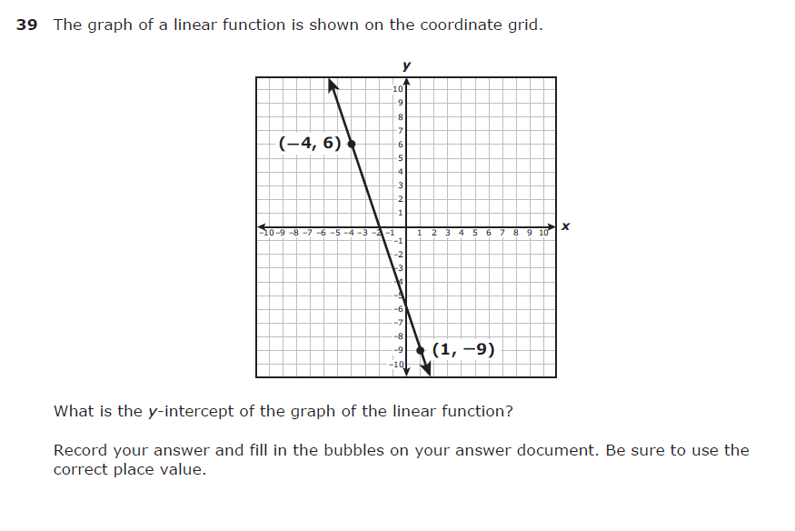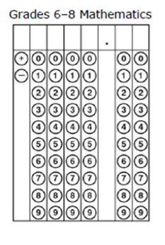

8.4C – 2 (R) twenty three W
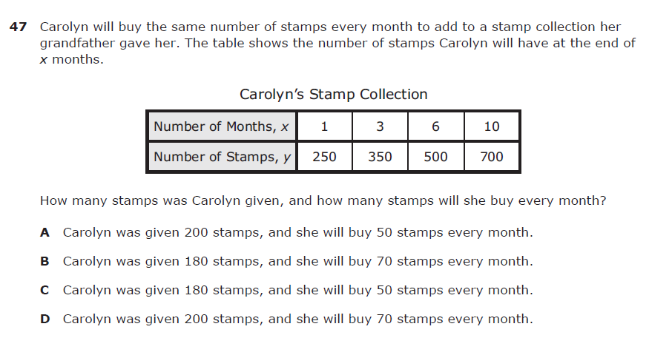

8.4C – 2 (R) twenty four X
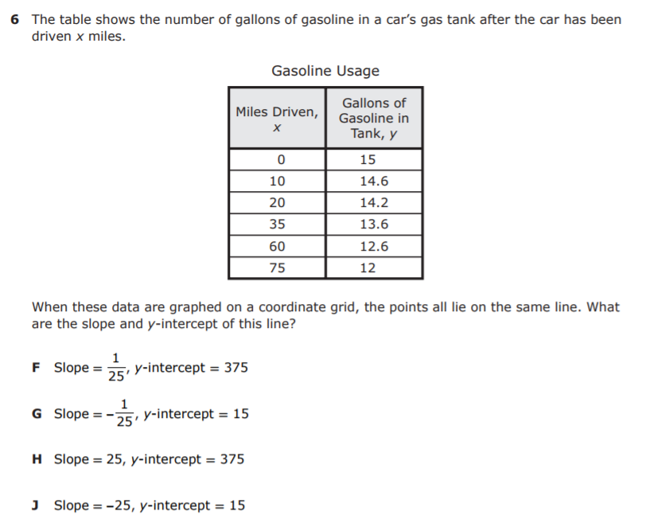
8.4C – 2 (R) twenty five W
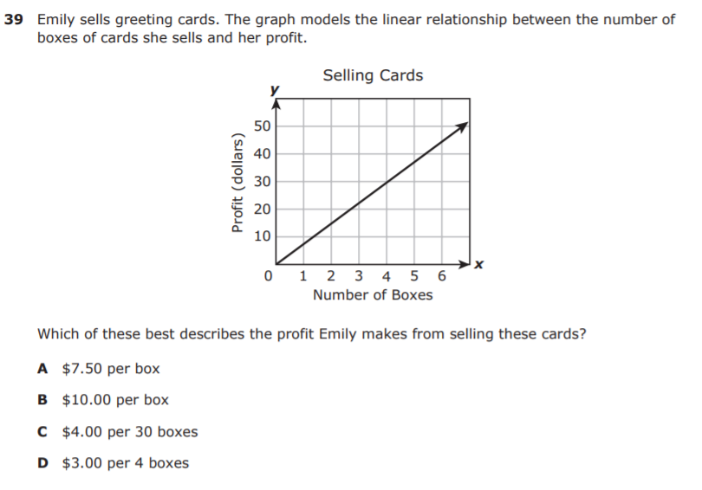
8.4C – 2 (R) twenty six W
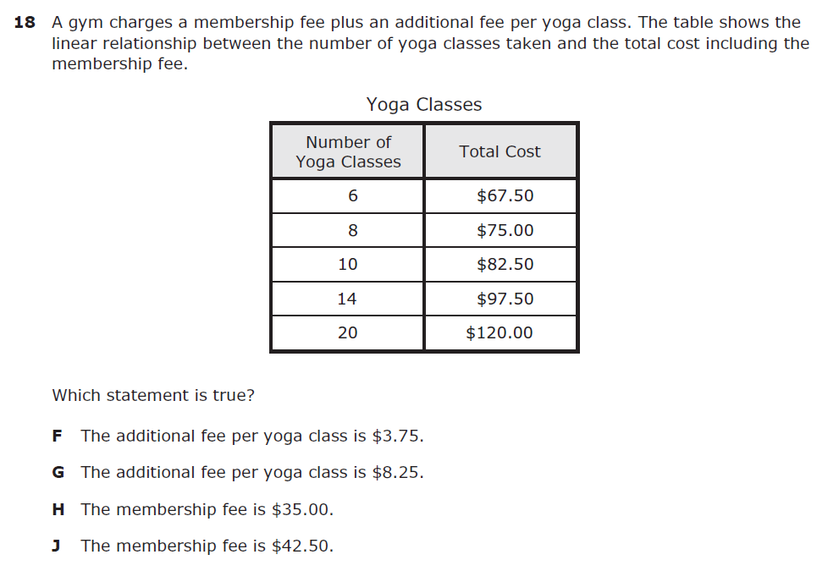
8.4C – 2 (R) twenty seven -5
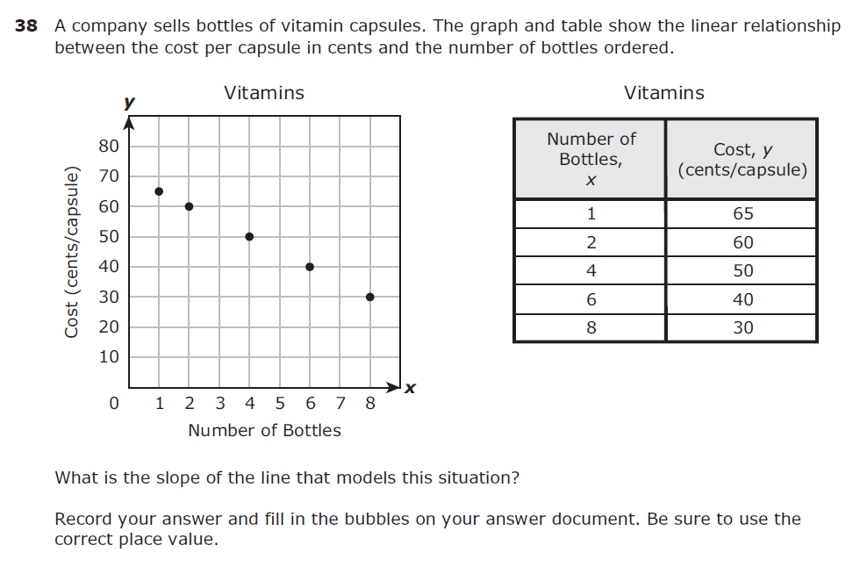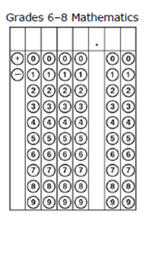

8.5D – 4 (R) twenty eight Z
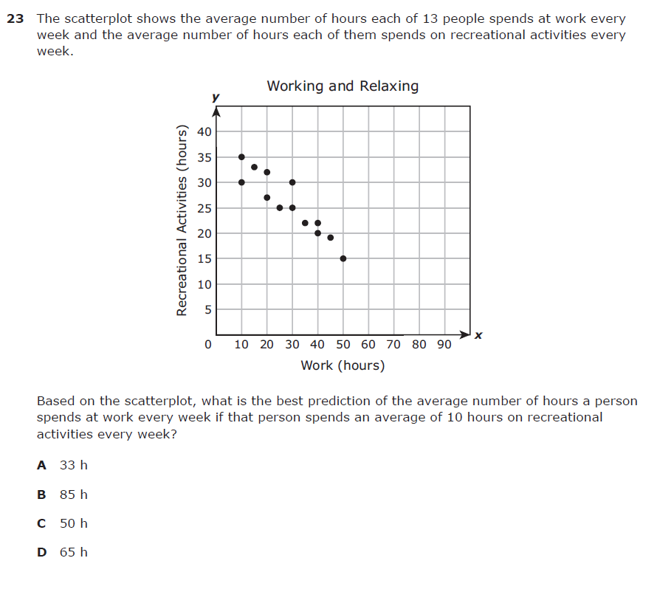
8.5D – 4 (R) twenty nine W
8.5D – 4 (R) thirty Y
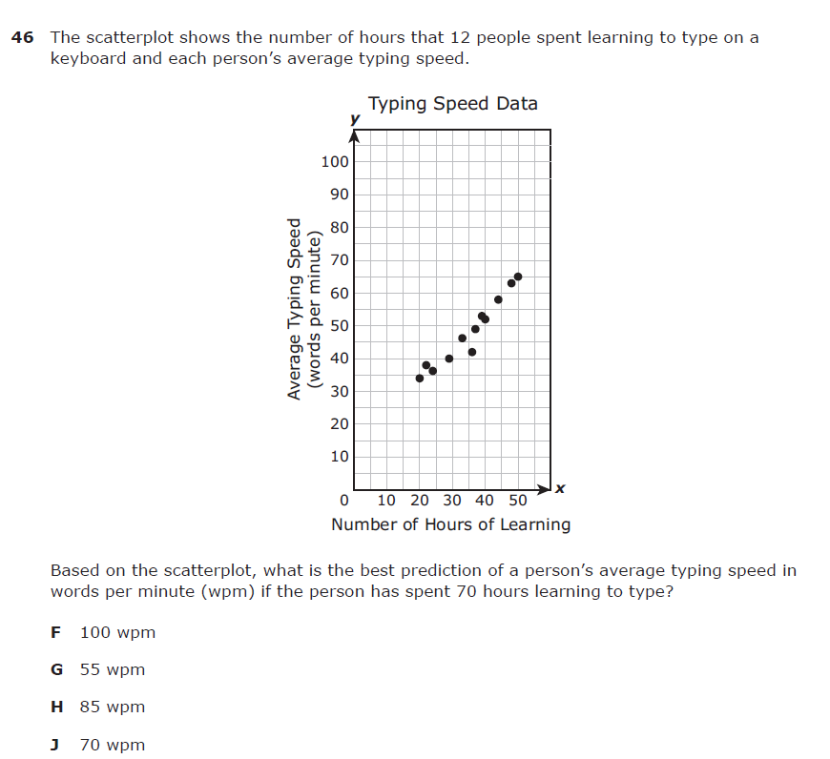
8.5D – 4 (R) thirty one W
8.5D – 4 (R) thirty two X
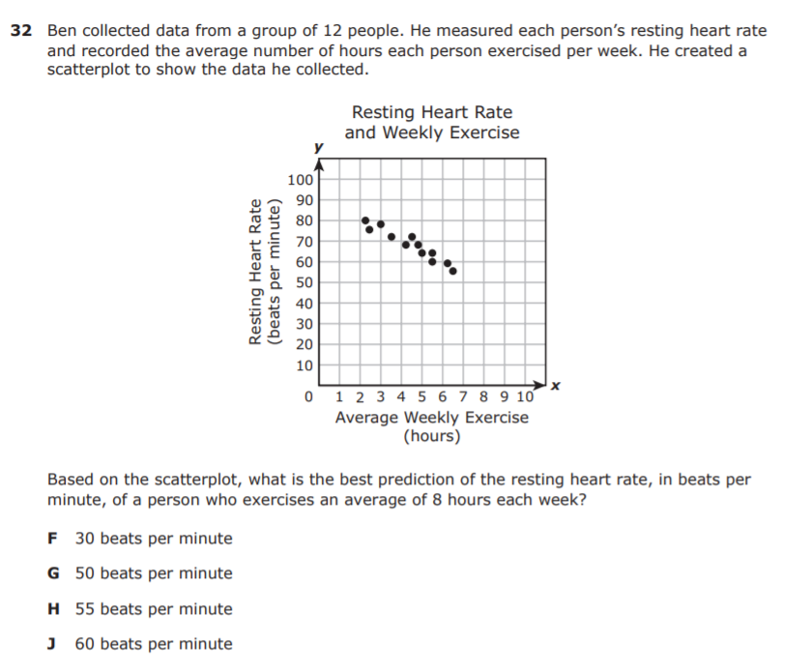
8.5D – 4 (R) thirty three Y
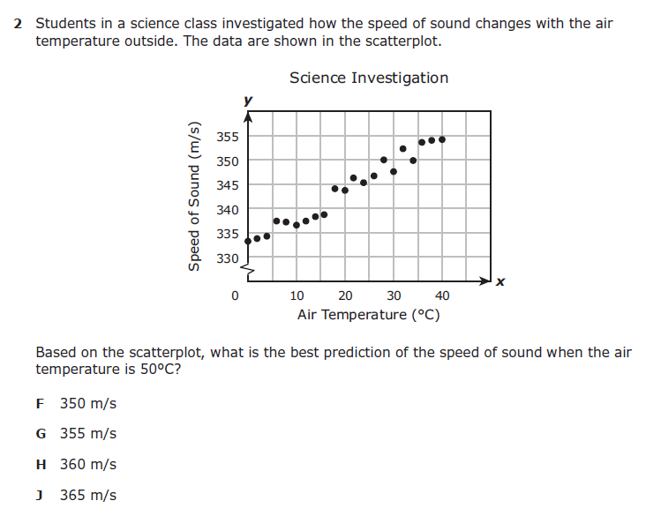
8.5D – 4 (R) thrity four W
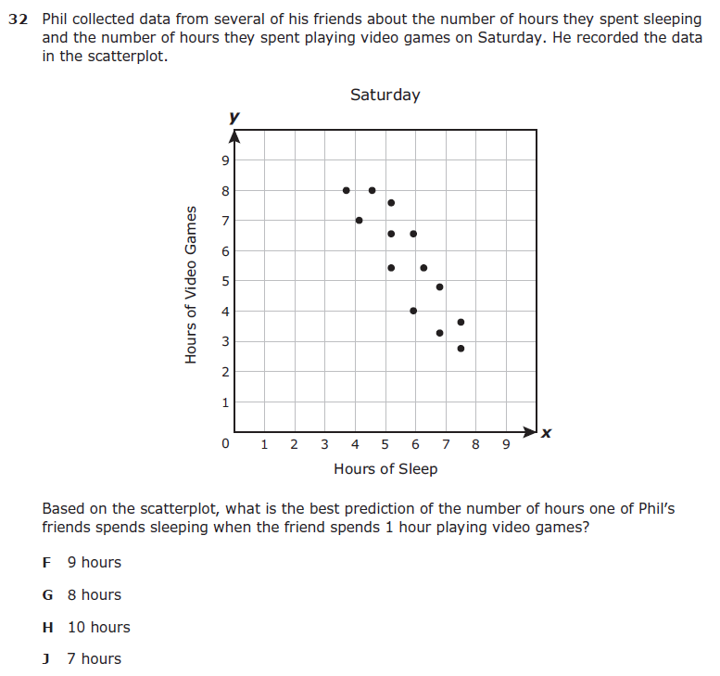
8.5G – 2 (R) thirty five W

8.5G – 2 (R) thirty six Y
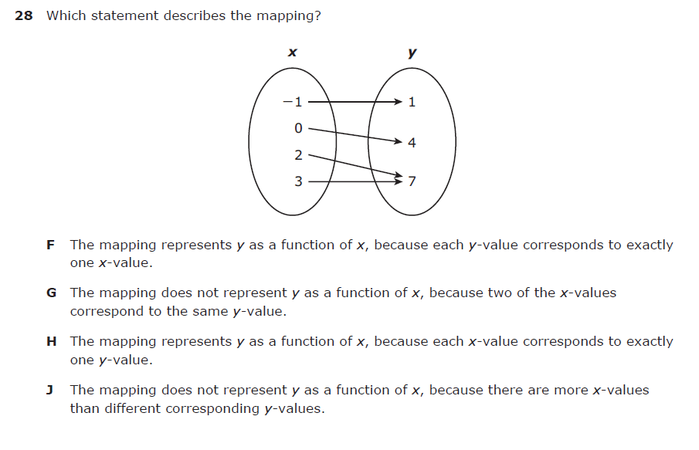
8.5G – 2 (R) thirty seven X
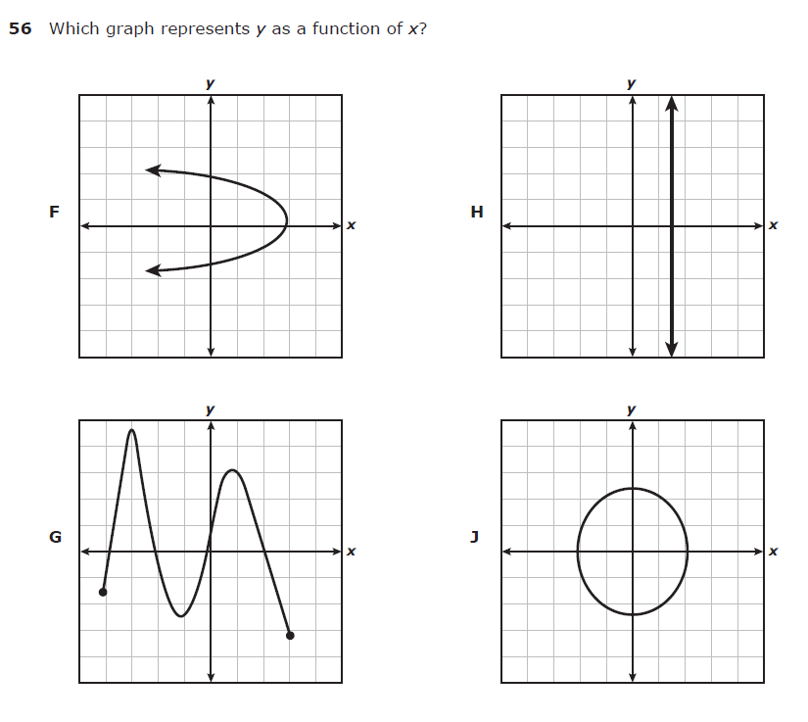
8.5G – 2 (R) thirty eight W
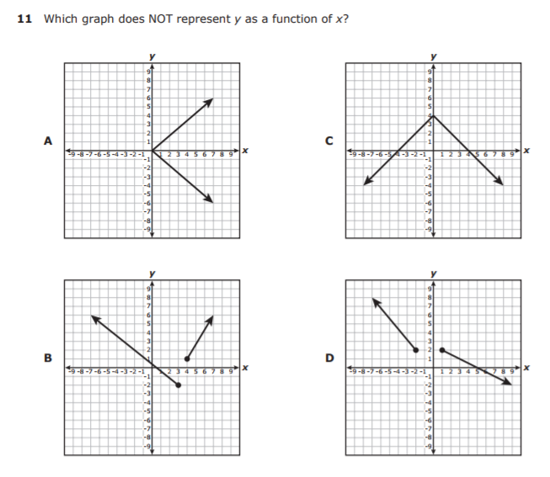
8.5G – 2 (R) thirty nine X
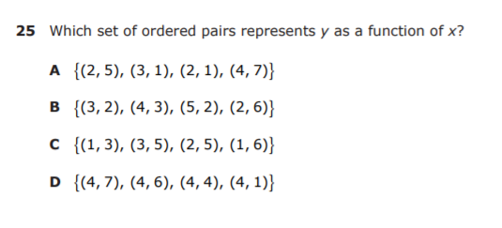

8.5G – 2 (R) forty Z
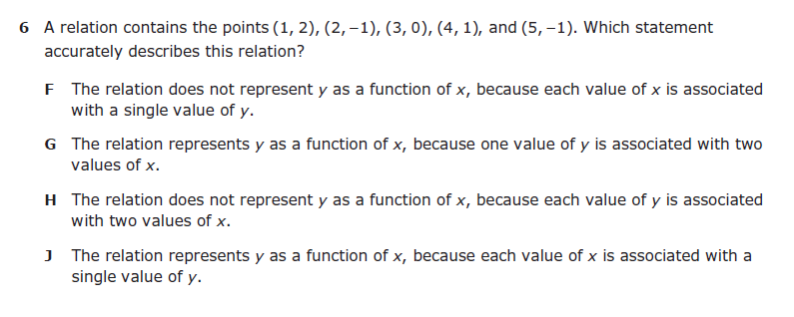

8.5G – 2 (R) foty one W
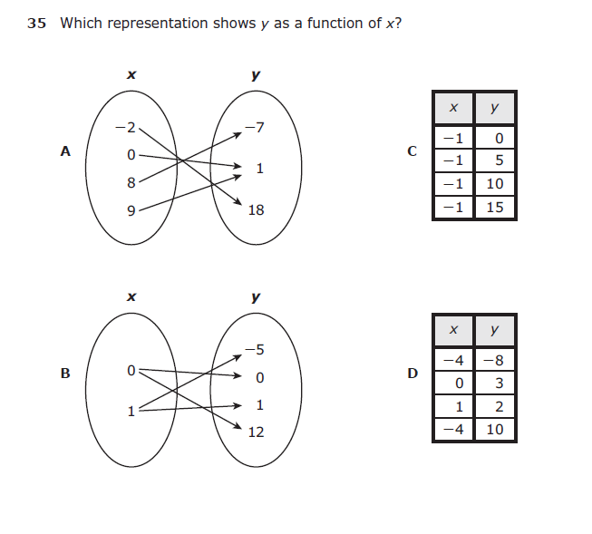
8.5I – 2 (R) forty two Z
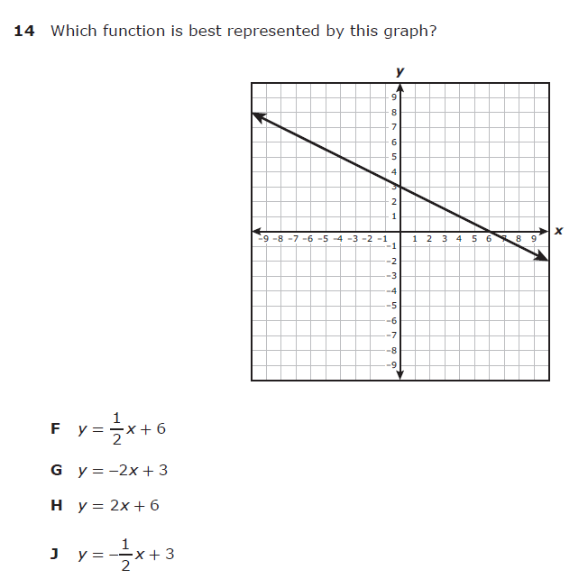
8.5I – 2 (R) forty three W
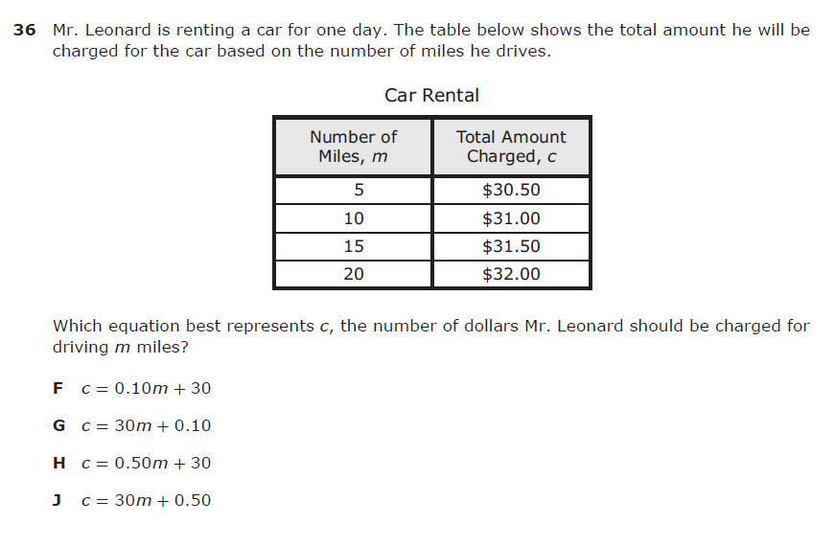
8.5I – 2 (R) forty four Z

8.5I – 2 (R) forty five W
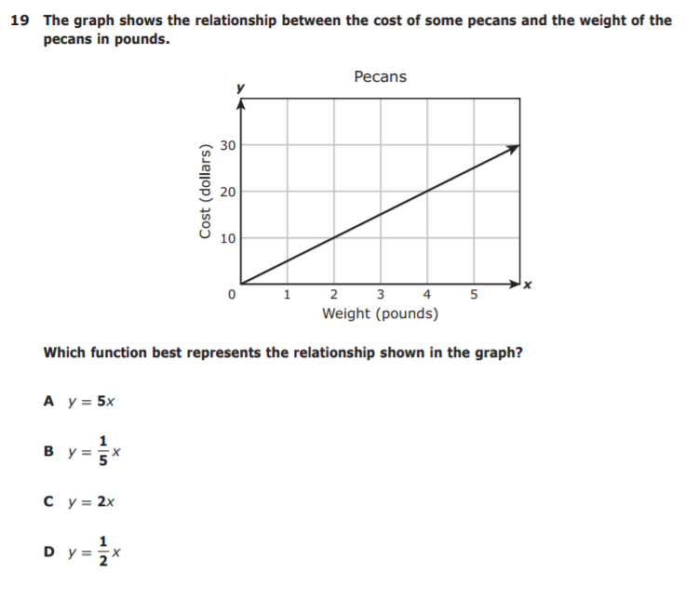
8.5I – 2 (R) forty six W
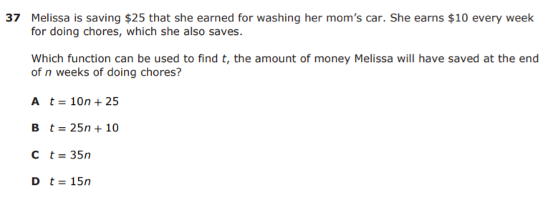

8.5I – 2 (R) forty seven X
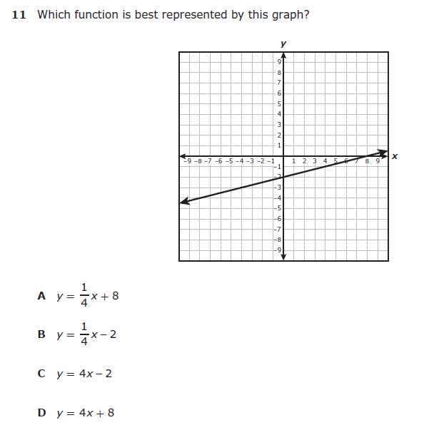
8.5I – 2 (R) forty eight Z
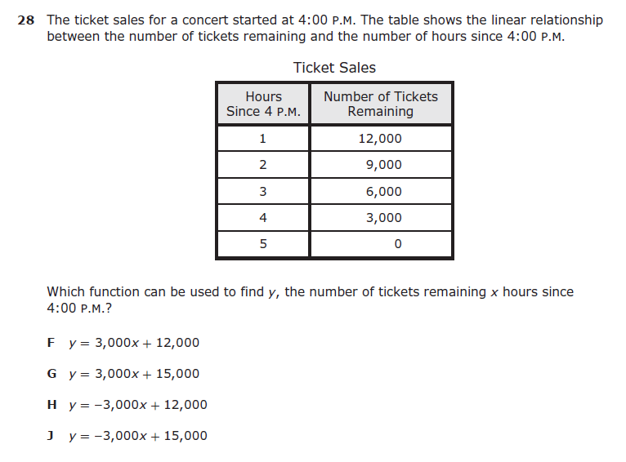
8.7A – 3 (R) forty nine Z
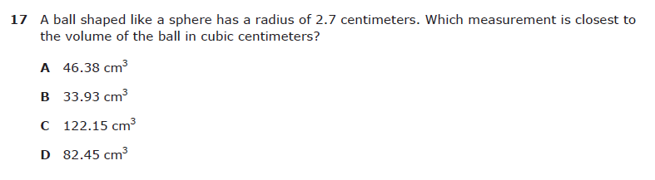

8.7A – 3 (R) fifty X
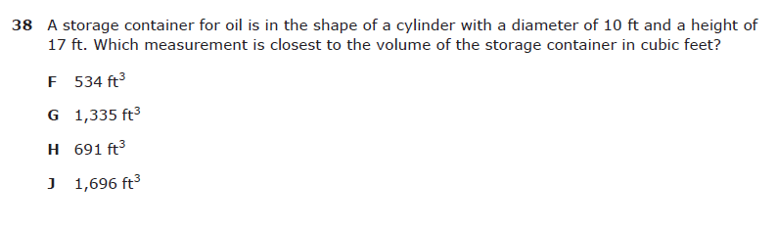

8.7A – 3 (R) fifty one W
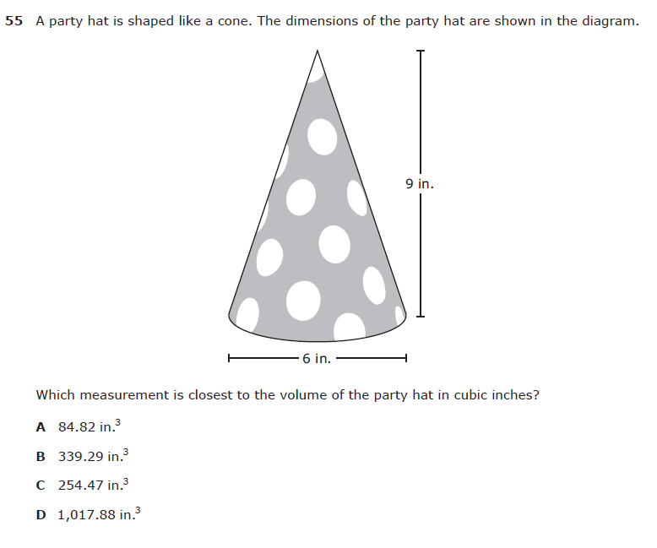
8.7A – 3 (R) fifty two Z
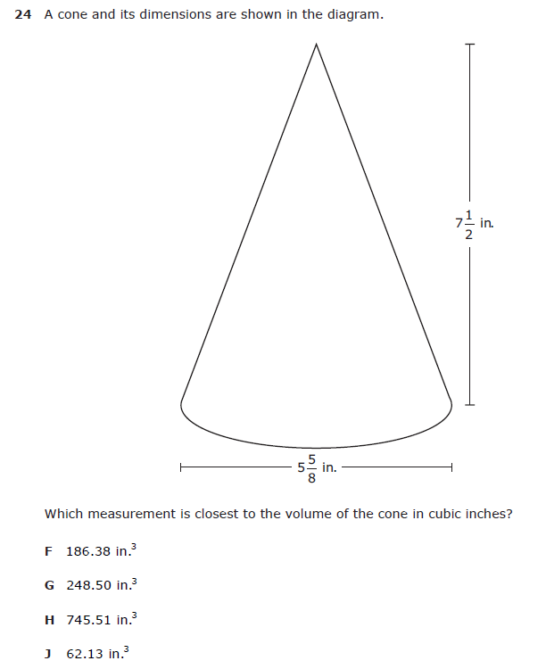

8.7A – 3 (R) fifty three X
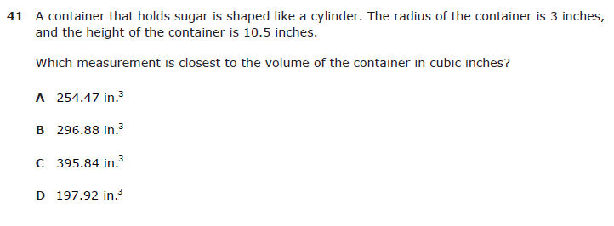

8.7A – 3 (R) fifty four W
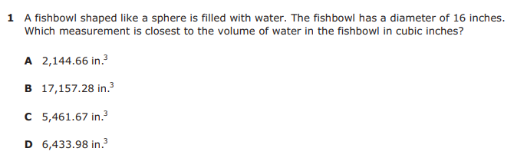

8.7A – 3 (R) fifty five Y
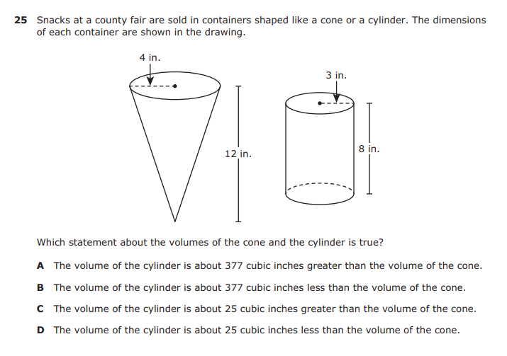
8.7B – 3 (R) fifty six X
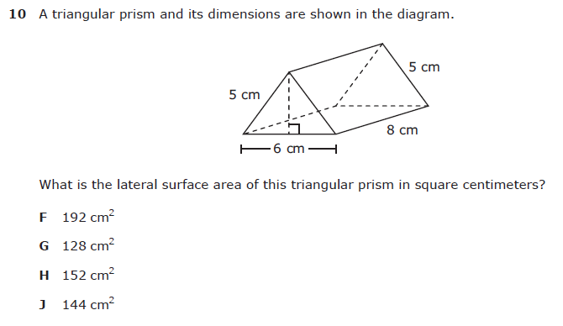
8.7B – 3 (R) fifty seven 102.16
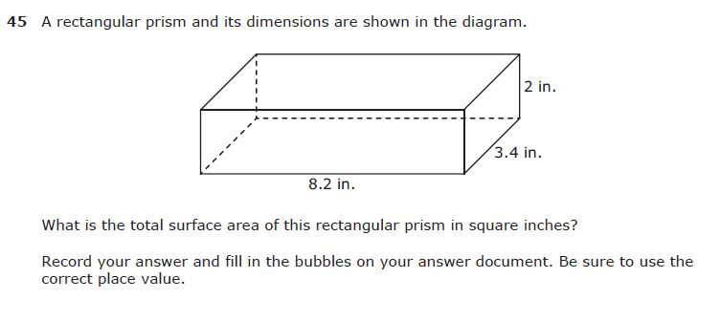

8.7B – 3 (R) fifty eight X
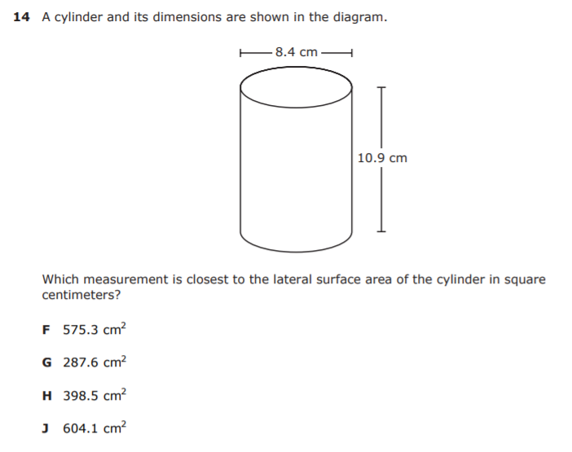
8.7B – 3 (R) fifty nine 237.5
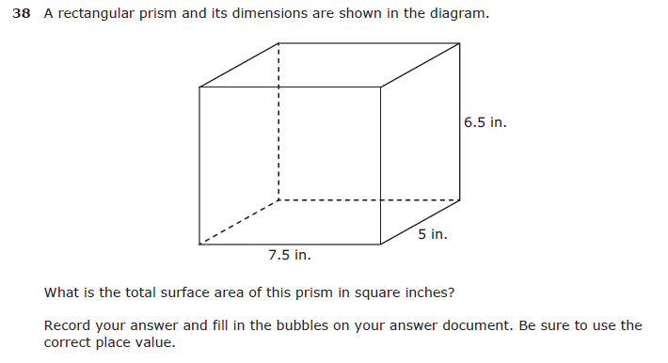

8.7B – 3 (R) sixty 270
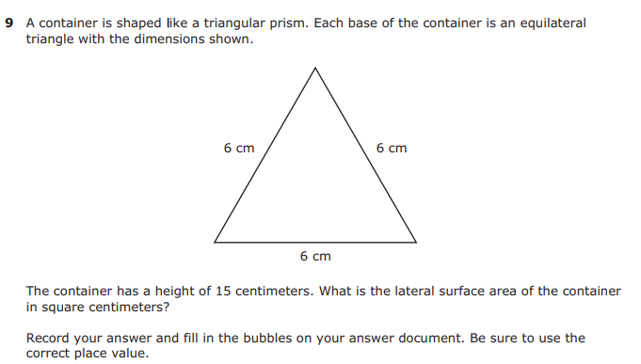

8.7B – 3 (R) sixty one Y
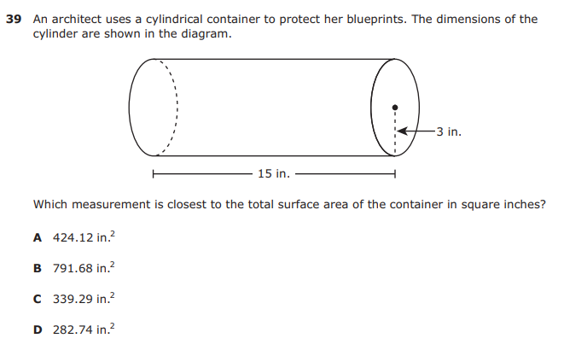

8.7C – 3 (R) sixty two 14
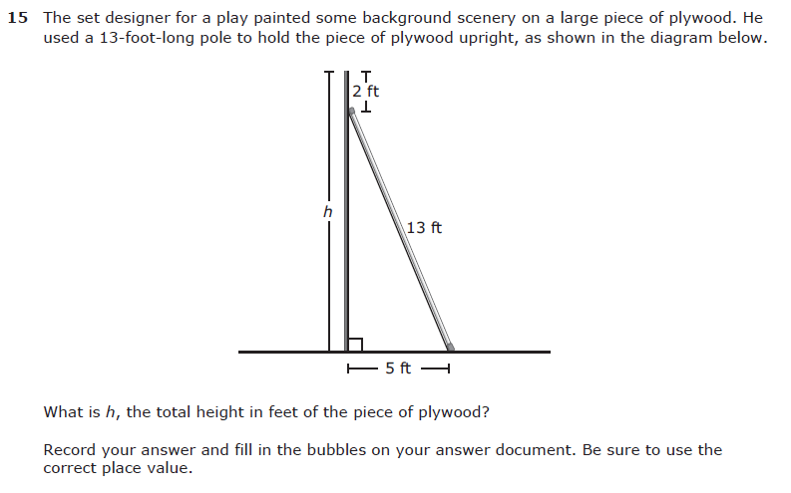

8.7C – 3 (R) sixty three Y
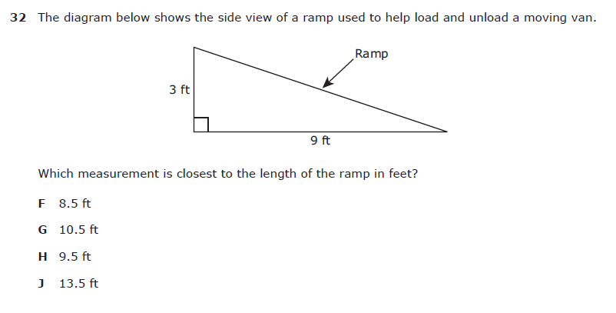

8.7C – 3 (R) sixty four 32.5
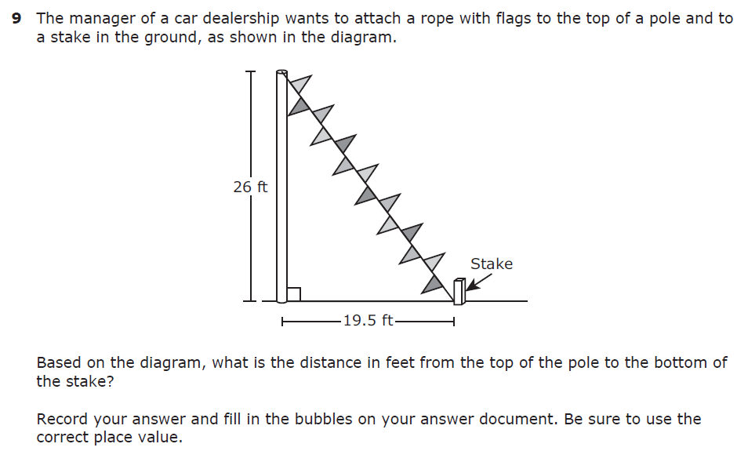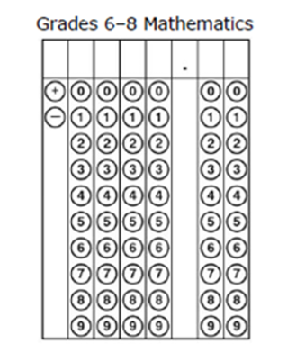

8.7C – 3 (R) sixty five W
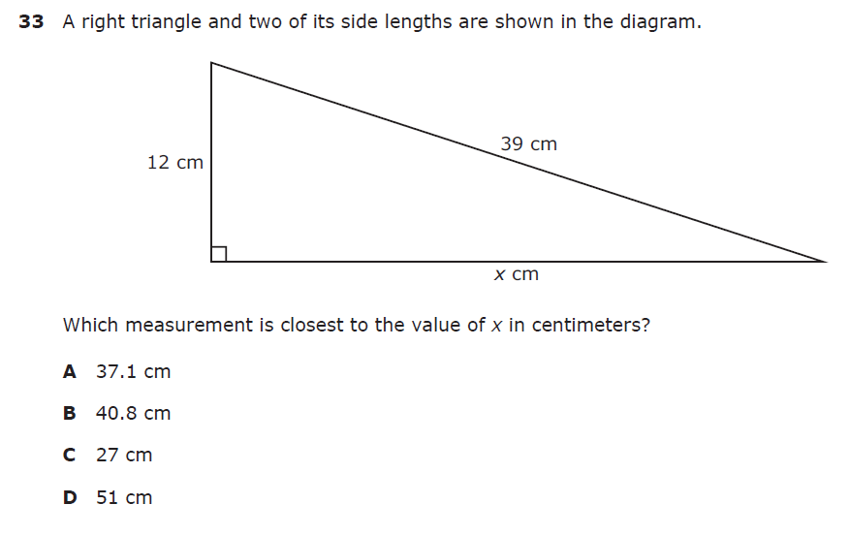
8.7C – 3 (R) sixty six X
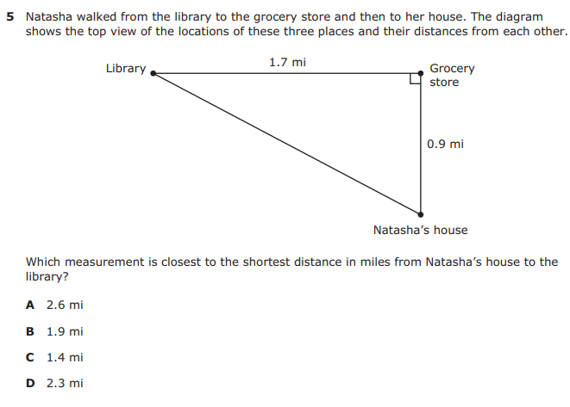
8.7C – 3 (R) sixty seven Z
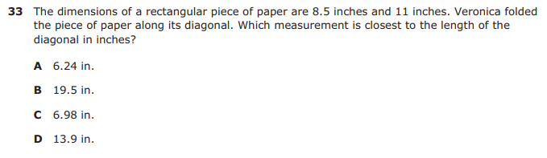

8.8C – 2 (R) sixty eight W

8.8C – 2 (R) sixty nine 2.25
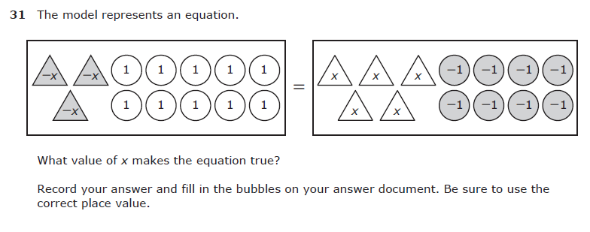
8.8C – 2 (R) seventy Z
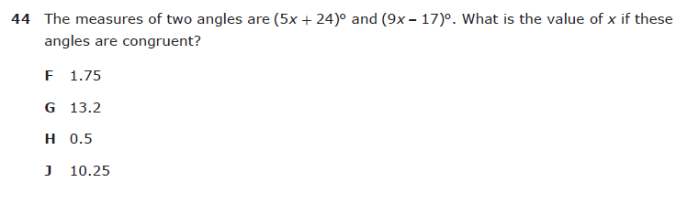

8.8C – 2 (R) seventy one Z
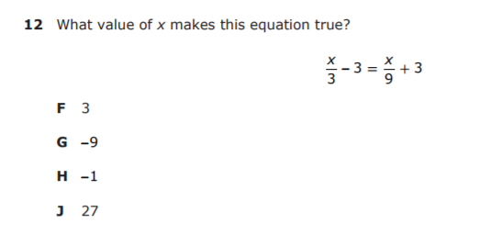

8.8C – 2 (R) seventy two 6

8.8C – 2 (R) seventy three Y

8.8C – 2 (R) seventy four -7
8.10C – 3 (R) seventy five Z
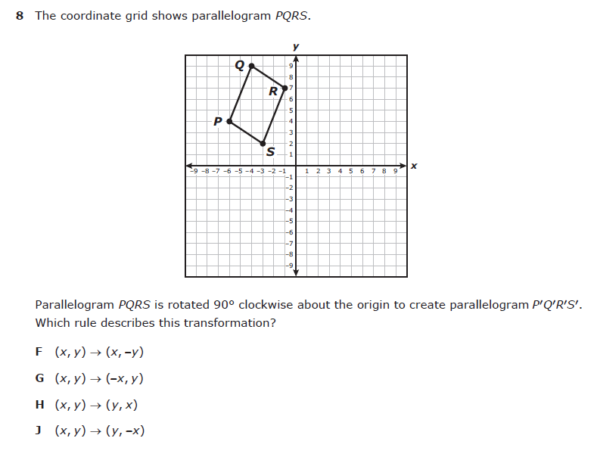
8.10C – 3 (R) seventy six X
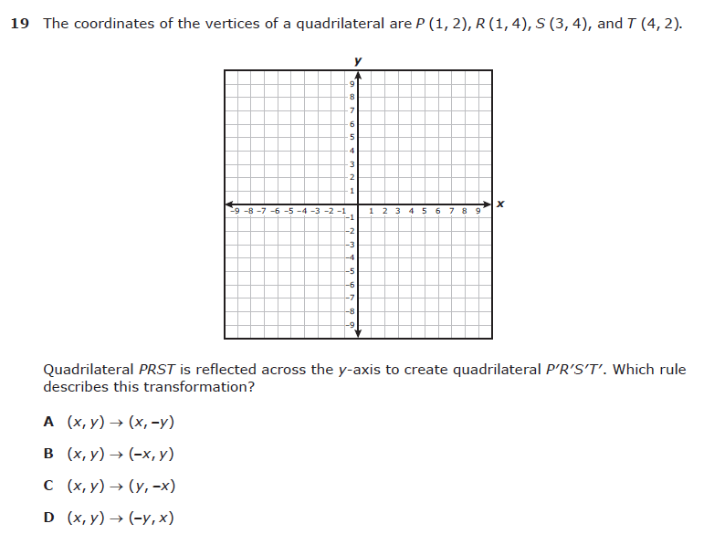
8.10C – 3 (R) seventy seven X

8.10C – 3 (R) seventy eight W
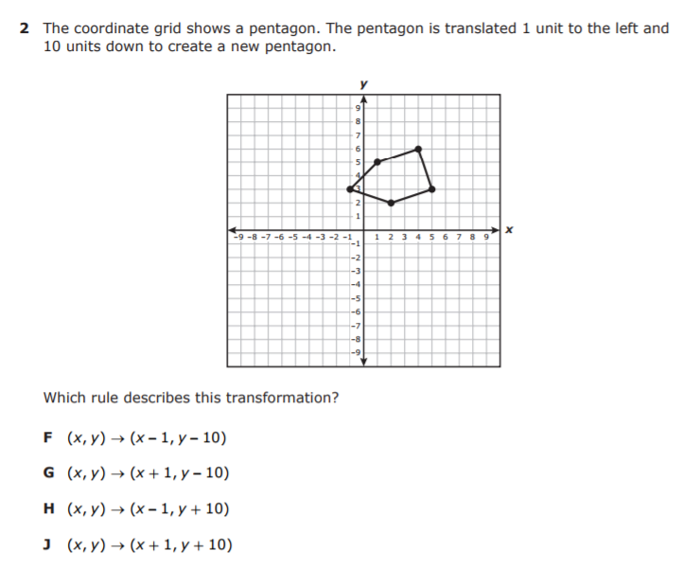
8.10C – 3 (R) seventy nine Y

8.10C – 3 (R) eighty W
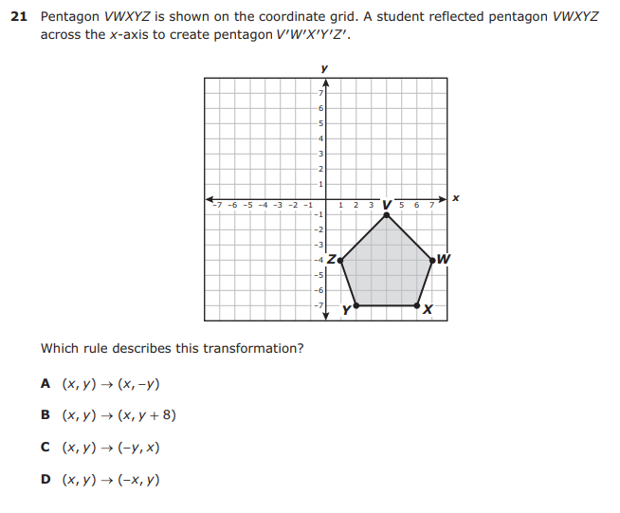
8.10C – 3 (R) eighty one Z
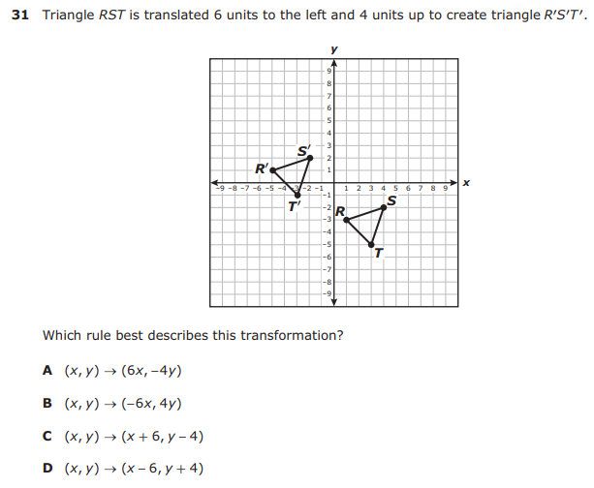
8.12D – 4 (R) eighty two W
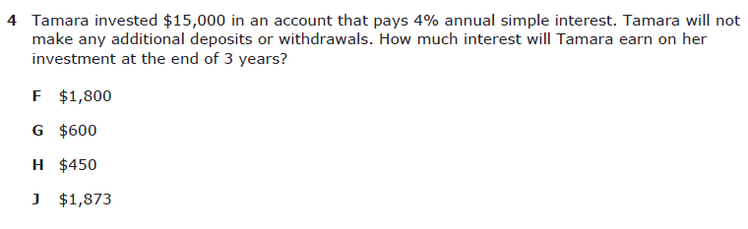

8.12D – 4 (R) eighty three Z
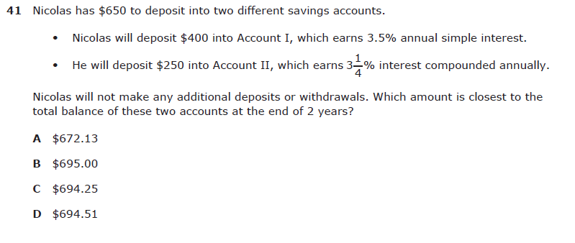

8.12D – 4 (R) eighty four W
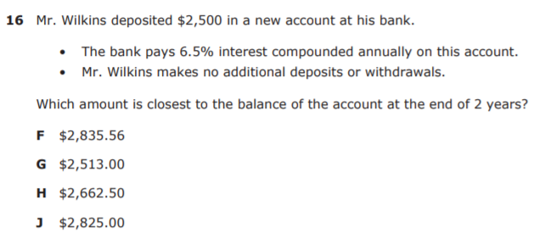

8.12D – 4 (R) eighty five X

8.12D – 4 (R) eighty six Z

8.12D – 4 (R) eighty seven X

